San Mateo County Health System
Health System Duty Officer (HSDO) Role and Emergency Resources

Getting Through the Initial 1-3 Hours of an Emergency



CONTENTS

CONTENTS 2
I. HEALTH SYSTEM DUTY OFFICER (HSDO) DUTIES AND RESPONSIBILITES 3
II. HOW TO CONTACT HEALTH SYSTEM MANAGERS 5
A. Health System Management Contact List 5
B. Cordilleras Facility Manager 5
C. Canyon Oaks Facility Manager 5
D. Human Services Agency Contact List 5
E. Public Safety Communications 5
F. HAZMAT Contact 6
G. Other Phone Call Resources 6
III. AGENCY REPRESENTATIVES/SCOUTS 7
IV. MESSAGES FOR LARGE GROUPS OF HEALTH SYSTEM EMPLOYEES 7
A. Automated Employee Hotline 7
B. California Health Alert Network (CAHAN) 8
C. San Mateo County Alert (SMC Alert) 8
D. All Staff Emails via GroupWise 9
V. CONTACTING OTHER PARTS OF THE COUNTY 9
A. How to reach other county departments 9
B. After Hours ISD/IT Support 9
C. How to reach the Office of Emergency Services (OES) 9
VI. ACTIVATING THE HEALTH SYSTEM DEPARTMENT OPERATIONS CENTER (DOC) 9
A. Accessing Equipment 10
B. Requesting Health Staff to Report to Work 11
C. Assigning DOC Roles 11
VII. USING A PORTABLE RADIO 12
VIII. SUPPLIES, EQUIPMENT & MEDICATIONS 13
A. What Technology Will Work and When: 13
B. Accessing Local Emergency Medications 14
Appendix A: INCIDENT ASSESSMENT FORM 15
Appendix B: ICS ORGANIZATION CHART 17
Appendix C: Contact Quick Sheet and Contact List for All Health System Managers 18
Appendix D: Instructions for Portable Radio Use 24
Appendix E: Satellite TV Instructions 26
Appendix F: Scout Contact Information 27
Appendix G: Human Services Agency Contact List 28
Appendix H: Updating This Document 29

HEALTH SYSTEM DUTY OFFICER (HSDO) DUTIES AND RESPONSIBILITES

Contact: (650) 670-xxxx
Email: hsdo@yourcountygov.org
Duty Statement: Receive and respond to calls from Public Safety Communications (PSC) for county emergencies where Health System functions may be needed other than EMS response and hazardous materials (HazMat); fill the position of Health/Medical Branch Director at the County Emergency Operations Center (EOC); assign initial DOC positions as required; while on-call, the Health Administrator would need to remain in the Bay Area and be available to answer the phone 24/7.
- Primary Responsibilities:
- Respond to the call from PSC
- Obtain briefing from OES, HSA, ARC, fire/law representative
- Determine if Health System involvement is needed beyond the EMS function and HazMat
- Dispatch Agency Representatives to scene for an assessment, if needed
- Notify the Health System Chief
- Notify the Public Information Officer (PIO)
- Approve the commitment of resources, if needed
- Carry all passwords, PIN numbers and reference materials at all times

- Secondary Responsibilities
- Receive assessment from Agency Representatives
- Determine the scope of the Health System response, i.e., stand up a virtual Department Operations Center (DOC), establish a full DOC, set up a command post on scene
- Assign additional personnel to the incident if needed
- Notify Health System executives
- Assemble a team that fills out the basic ICS command positions of logistics, planning, operations, PIO
- Consult with team and determine strategy for the next twelve hours
- Approve action plan as provided by Planning Chief
- Approve public messages/press release/social media

- Ongoing Responsibilities
- Ensure documentation of all actions taken
- Ensure accounting job code has been assigned by finance
- Develop briefing for change of command

- Likely Order of Events
- Receive call/page from Public Safety Communications, Office of Emergency Safety (OES), Human Services Agency (HSA)
- Contact OES and receive briefing from OES Duty Officer and/or HSA
  - Determine if Health Agency representatives should be sent to the scene
- If no Health System involvement STOP HERE; otherwise continue
- Notify Health System Chief or Health System Deputy Chief
- Contact Health Agency Representatives/Scouts:
  - Check schedule for on-call assignment (Appendix F)
  - Call directly via listed phone number OR use CAHAN
  - Meet via conference call OR portable radio channel HEALTH1
  - Keep a log of all information, contacts, decisions by date, time
- Describe situation to Health Agency Representatives, provide the incident address with instructions to fill out the assessment form (Appendix A) upon arrival at scene and when to get back in touch with you.
- Receive briefing and assessment from Health Agency Representative(s)
- Based upon assessment
  - Determine if additional resources and personnel are needed to support the event
  - If the DOC has been activated, assign staff to the Incident Command System organization chart (Appendix B)
- Notify Public Information Officer (PIO)

HOW TO CONTACT HEALTH SYSTEM MANAGERS
Health System managers can be contacted by using contact lists including home/cell phone information or by calling Public Safety Communications which maintains a pre-set Health System call list (the Health System determines who is on this list and it does not include all managers).

Health System Management Contact List
See Appendix C: Contact List for All Health System Managers including Public Information Officers and Health Executive Committee.

San Mateo Psychiatric Residential Facility On-Call 24/7
(650) 367-xxxx

San Mateo Adolescent Residential Facility On-Call 24/7
650-839-xxxx

Human Services Agency Contact List
See Appendix G

Public Safety Communications
Public Safety Communications has a list of Health System division leaders that they will contact on our behalf. Anyone who knows the CAP Code can initiate a call. A message that you provide goes to everyone on the list at the same time. The message goes to the home or cell # that each person provided Public Safety Communications.
Call 911 if you are in San Mateo County
Call (650) 363-xxxx outside San Mateo County
When the dispatcher answers, tell him/her you want to send a message to
CAP Code: xxxx

CAP Code xxxx members:
(list of members)

San Mateo Medical Center
The ISD Operators will give you the number of the hospital administrator on-call. You can reach the ISD Operator at (650) 573-xxxx.

HAZMAT Contact
Call 911 for Hazardous Materials response (Environmental Health)

Other Phone Call Resources
AT&T Teleconference User Instructions
To initiate a conference call, notify participants of the Dial-In-Number and Participant Access Code. Dial In Number: (888) 808-xxxx
- (International Access/Caller-Paid Dial In Number: (213) 787-xxxx
- Enter the Host code if you are the host: xxxxxxx
- Or enter the Participant code: xxxxxxx

Note: If the Host has already joined the call, participants will be joined automatically. If the Host has not yet dialed in, participants will be placed on hold until the Host does join. If the Host does not join the conference within 15 minutes of the first participant joining, the conference will end.

GETS Card: If you are having trouble with busy phone lines or calls not going through
The Government Emergency Telecommunications Service (GETS) is a service that provides users with priority usage to telephone and cell phone providers.

When calling from a land line: 1-710-627-xxxx; at the prompt enter the 10-digit number you are trying to reach
When calling from a cell phone: *(star) 272, 1-710-627-xxxx; at the prompt enter the 10-digit number you are trying to reach

A prompt will direct the entry of your PIN and the destination telephone number. Once you are authenticated as a valid user, your call is identified as a National Security/Emergency Preparedness call and receives priority handling. The following Health System staff are registered for the GETS service.
Subscriber | GETS Land Line | GETS Mobile
John Doe | Yes | Yes
Sue Smith | Yes | Yes
David Applebee | Yes | Yes

AGENCY REPRESENTATIVES/SCOUTS

Phone: (650) 670-xxxx
Email: Scout@yourcounty.org

Definition: Agency Representatives are Health System employees who are, upon your request, able to report to the scene of an emergency and report back the facts of the situation using a “Scene Assessment Form” (see Appendix A). The facts presented should be enough to allow you to determine the scope of the Health System response.
See Appendix F for roster and contact information.

MESSAGES FOR LARGE GROUPS OF HEALTH SYSTEM EMPLOYEES

Automated Employee Hotline
All employees have the following Health Employee Phone-in Numbers on the back of their DOC identification badge or disaster service worker card and are trained to call in for information about the effect of an emergency on Health System operations as well as to be apprised of any reporting instructions.
- 877-406-xxxx for the Health System except SMMC
- 877-406-xxxx for San Mateo Medical Center

INSTRUCTIONS: How to Record or Edit Employee Notification Announcement

Write out the announcement before you call.

For the Health System and San Mateo Medical Center: Call (800) 658-xxxx. You will be prompted for the following information.
- Enter the User Access Code: xxxxxxx#
- Enter the PIN: xxxxxxx#
- Pause while entries are validated
- Enter the Announcement ID and #: Health: 33xxxx# or SMMC: 35xxxx#
- Press 1, if correct.
- Entry combination is validated; the status is confirmed as Updateable, and whether the Announcement is shared.
- Record at the tone and press # when complete. Press any digit to cancel. Maximum recording length is 4 minutes.
- To listen to the new recording, press 0.
- To approve, press 1
- To re-record, press 2
- To cancel, press 6
- To update another Announcement, press 1. To exit, press 7 or hang up.
Allow up to 15 minutes for this update to be completed and the new announcement to become active. Until the new announcement is active the previous recorded announcement will be played.

The standard message on the line is:
You have reached the notification line for the County of San Mateo. At this time all facilities are operating normally and no disruptions are expected. Employees should report to work as scheduled. If an emergency arises, this message will be updated. Thank you.

California Health Alert Network (CAHAN)
CAHAN is a web-based program that allows messages to be sent en masse or individually via any form of communications equipment that members have listed as available or in use. All Health System employees are required to register for CAHAN. All Health System Division Directors have been trained to issue an alert.

To send a CAHAN alert:
- Log in to CAHAN at https://cahan.ca.gov
- Click on “Alerts” in the top gray area

San Mateo County Alert (SMC Alert)
SMC Alert is a web-based program reliant upon users to self-enroll. In an emergency situation, an alert will be sent by an OES designated SMC Alert administrator. Employees who have signed up will receive emails and/or several text messages on their cell phone or mobile device.

SMC Alert Information: www.smcalert.info

To send an alert through SMC Alert, contact the Office of Emergency Services Duty Officer through Public Safety Communications (650) 363-xxxx.

All Staff Emails via GroupWise
An All Health System email can be sent from a GroupWise Account and will go to employee’s work email address. The GroupWise group is: Health-All Employees.

CONTACTING OTHER PARTS OF THE COUNTY

How to reach other county departments
Most other departments have an on-call administrator. To reach these people, call Public Safety Communications (650) 363-xxxx (PSC Supervisor) and ask for the person by name.

After Hours ISD/IT Support
ISD engineers are available on an on-call basis to respond to problems with radio and microwave systems, the telephone system, the data network, the Intranet and the GroupWise email systems. For assistance with any of these issues during after-hours and weekends call (650) 573-xxxx then press #3.

How to reach the Office of Emergency Services (OES)
The County EOC when fully operational is located in the basement/jury selection room of xxx County Center in Redwood City. Cell phone signals and radios do not work. Telephones most likely will not be answered due to the activity in the center. Call PSC at 650-363-xxxx (PSC Supervisor) and ask to speak to the OES Duty Officer or Call (650) 573-xxxx for the OES office front desk.

ACTIVATING THE HEALTH SYSTEM DEPARTMENT OPERATIONS CENTER (DOC)
If it is determined by the Health System Duty Officer that the Health System will have extensive involvement in the emergency event, open the DOC. The declaration to open a DOC may be made by the Health Officer, Health System Chief, Health System Deputy Chief, or any division director.

In a major emergency, expect contact from OES, PHEP or EMS to request that the DOC be opened.

The physical location of the DOC can be opened by any representative of the Public Health Emergency Preparedness Unit (PHEP): John Doe, Susan Smith, David Applebee. All of these people can be reached by calling Public Safety Communications (911) or (650) 363-xxxx (PSC Supervisor). Members of the 4 DOC teams are also trained and have practice opening the Room 100 location.

The Health System Duty Officer may open the DOC virtually, i.e., manage the incident remotely from homes or offices.

Accessing Equipment

KEYS

The following keys hang just outside of the Public Health Emergency Manager’s cubicle, to the left side of Room xxx on entry – call security (650) 573-xxxx for access to Room xxx:
- Room 100 Computer Room
- Room 20 and audio/visual cabinets
- Room 101
- Room 100 supply closets operate by Key Pad code xxx
- Medical Supply Warehouse, xxx Rollins Road, Burlingame

SUPPLY CLOSETS

ROOM 100 (Key Pad Code for Closets. Press 1, then 3, then 4. Open)
- Planning Section Supplies –T-Card Rack, T-Cards, ICS Forms; Planning Kit (Kits include: Binder, Vests, JAS, Pens, Paper, etc); all hard copy forms necessary to create an Incident Action Plan
- Logistics Section Supplies – FRS radios and land-line telephones, Fax and computers; Logistics Kit
- Operations Section Supplies – Operations and Finance Kits
- Computer Access – Computer Room – (Locked room back right of stage). Key maintained with Health Administration (ext 2xxx) or Rm xxx.
- Audio-visual equipment: Microphones, Projector, Audio (Health Admin ext 2xxx can assist)
- Satellite access – (Instruction manual in room or at health admin desk).
Room 101 Locked closet left wall outside entrance to room 100, holds:
- 10 GoKITS for Vaccination Clinics (each kit ready to serve ~ 300)
- 10 Emergency Shelter Backpacks for full support of PHNs deployed to a shelter.
- Flu Vaccine Clinic Support items – Promotional Signs, and flip board paper
- Headsets for telephones;
- Backpacks for emergency response
ROOM 20 (Conference room next to kitchen on ground floor)
- Computer access
- Satellite television access (news broadcasts) See Appendix E for instructions
- Printer and Fax access
ROOM 106
- Ham and trunked radios and battery storage
- Satellite telephone equipment storage
- EOC Communications Directory of Ham and other radio and Satellite channels and call numbers.
CHEMPACK ROOM (Locked and monitored room located inside the mailroom)
- Nerve/chemical agent antidotes, antibiotics, psychological medications
- Red box on wall contains key to room; break glass to access
- When key is used to open door, alarm will sound and SMMC Security will be summoned
- Authorized access: Health Officer, PHEP Manager, SMMC Pharmacy Director

Requesting Health Staff to Report to Work
All employees have the following #s on their badge and are supposed to call for information about the effect of an emergency on Health System operations and reporting instructions.
- 877-406-xxxx for the Health Department
- 877-406-xxxx for San Mateo Medical Center
Instructions for accessing and recording the message can be found in Section II: Part A “Employee Messaging: Employee Notification Phone”

Assigning DOC Roles
Those who have undergone ICS and DOC training and participated in exercises are assigned to a team and given a DOC role. There are four teams (Teams A-D). Roles for managers are listed in Appendix C.

USING A PORTABLE RADIO
A portable radio should be used when you want to reach everyone who is on a portable radio at once or when no other forms of communication work. The following people have an assigned Radio at home:
LAST | FIRST | TITLE | CALL SIGN

Notes: Use call signs only during radio communications; do not use personal names – scanners may be in use by the media/public. See Appendix D: Instructions for Portable Radio Use.

Channels
Default Emergency Channel: COCOM4
Back-up Channel: HEALTH1 and COCOM2
COCOM1 is used by Hospital Security only; not to be used by Public Health.

SUPPLIES, EQUIPMENT & MEDICATIONS

What Technology Will Work and When:

Type if Equipment | When to use | Location | Function
Land line telephone | Any time | Cubicle/home | Voice communications
Cell telephone | Any time | On your person | Voice, text, photos
Text messaging | When voice will not go through | On your person | Text
GETS Card | When all telephone/cell lines are busy | On your person | Enables priority use of telephone/cell
Trunked Radios | When none of the above works and/or as instructed | Room 106 and as assigned | County-wide 2-way communications via assigned channels
PC & Apple Notebooks | As needed to run DOC | Room 106 | Data/word processing, email, internet
HAM Radios | When all telephone and cell services are not functional | Room 106 | Radio communications, text messaging
Portable System Interface (PSI) F4W | When telephone or cell unavailable; need remote LAN and wireless telephones | Room 106 | Wi-Fi, wireless VOIP telephones via a) LAN port, b) USB Card, c) Satellite Internet service
Note: Power Outages: 225 37th Ave. is served by an emergency generator with fuel for 3 days; all power outlets will function. At home, use your accessory power outlet in your vehicle to recharge PDAs.

Accessing Local Emergency Medications

Local Pharmaceutical Stockpile
The stockpile is located in a secure room of the xxxxxxxx building. The release of the pharmaceuticals is dependent upon the type and scope of the event. During shortages, some of the contents may be borrowed and subsequently replaced. During emergencies, select items may be deployed to hospital or field units. In broad terms, the contents are meant to counteract poisoning, influenza, exotic infections, chemical/nerve agent exposure, radiation, psychotropic medication shortages, emergency medical trauma medication shortages.

Maintenance, including rotation of stock, registration, and inspections, is conducted by: Health Officer, Public Health Emergency Preparedness Manager, SMMC Pharmacy Director. A card key and PIN is used to enter the area.

Emergency access by: San Mateo Fire Department (24/7/365); Emergency Medical Services (EMS) Personnel; Public Health Emergency Preparedness (PHEP) Personnel; SMMC Pharmacy Personnel. A hard key is located in a red box on the wall; break glass and retrieve key. When used in the door, an alarm will sound and SMMC Security will be summoned.

Appendix A: INCIDENT ASSESSMENT FORM
INCIDENT ASSESSMENT |  | 1. Incident Name |  |  | 2. Your Name  2a. Cell |  |  | 3. Date | 4. Time
INCIDENT DEMOGRAPHICS
5. No. of People Affected | 6. No. of People Displaced |  |  | 7. No. of People Injured |  |  | 8. No. of Deaths
9. No. of People DME | 10. No. of People Rx |  |  | 11. No. of People Psych |  |  | 12. No. of People Frail
13. AGE RANGE
0-13 Qty: | 14-20 Qty: |  |  | 20-64 Qty: |  |  | 65 + Qty:
14. INCIDENT MAP/LOCATION
Shelter Evacuation Center
ON-SCENE ORGANIZATION
15. Incident Commander  Cell: |  |  | 16. Public Information Officer  Cell: |  |  | 17. Liaison Officer  Cell:
18. Office of Emergency Services  Cell: |  |  | 19. American Red Cross  Cell: |  |  | 20. Human Services Agency  Cell:
21. Incident Type (check one): Fire – Structure Fire – Wildland Flood Earthquake Power Outage
Hazardous Spill/Plume Tsunami Severe Weather
Plane Crash Train Crash Vehicle(s) Crash
Intentional Nerve/Chemical Agent Bio-Terrorism Other: ________________

22. Are agencies on scene sufficiently managing incident? YES NO
HEALTH RESOURCES
23. Immediate Equipment Needs
Laptops Caution Tape Other _____________________
Portable Wifi/VOIP phones (F4W) Wireless USB card Other _____________________
Portable Public Address System Crowd Control Stanchions
24. Are client needs being sufficiently managed by existing resources? YES NO
25. Immediate Objective(s) Psych. First Aid Senior Assistance Rx Refill DME Replacement Other
26. Resource Type
 | MD | RN/PHN | Senior Case Worker | Pediatric Case Worker
Requested
On Scene
Need
27. Estimated Duration of Event:
28. Notes:

Appendix B: ICS ORGANIZATION CHART – FIRST HOUR

 |  |  |  |  |  | Incident Commander
 |  |  |  |  |  |  |  |  |  |  | PIO
Operations Chief |  |  |  | Planning Chief |  |  |  | Logistics Chief |  |  |  | Finance Chief

Appendix C: Contact Quick Sheet and Contact List for All Health System Managers

 | Name | Title | Cell Phone | Home Phone | Pager | Radio Code | On CAP list (Y/N) | DOC Assignment
HEC Members
(Health Executive Committee)
Public Information  Officers | Press Phone
Public Information  Officers | PIO
Public Information  Officers | Assistant PIO
Public Information  Officers | Assistant PIO
Other Resources | Public Safety Comm
Other Resources | Cap Code Reference
Other Resources | County Hospital Administrator On Call
Other Resources | Office of Emergency Services
Other Resources | DOC Door Code
Other Resources | Health Officer On Call
Write Down | CAHAN  Password
Write Down | GETS Pin

Division/Role | Last Name | Cell Phone | Home | Pager | Personal Email | DOC Team | DOC Role | Work
BHRS
BHRS
PHPP
HCU
PHPP
CHS
PHPP
BHRS
BHRS
FHS
BHRS
Health Officer
SMMC
CHS
BHRS
BHRS
BHRS
HEC - SMMC
PHPP
SMMC
AAS
SMMC
HEC - Chief
PHPP
BHRS
PHPP
FHS
PHEP
FHS
BHRS
SMMC
BHRS
CHS
AAS
BHRS

Appendix D: Instructions for Portable Radio Use

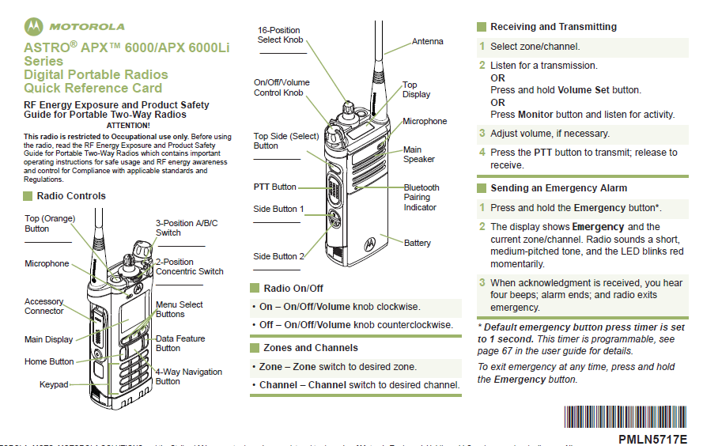

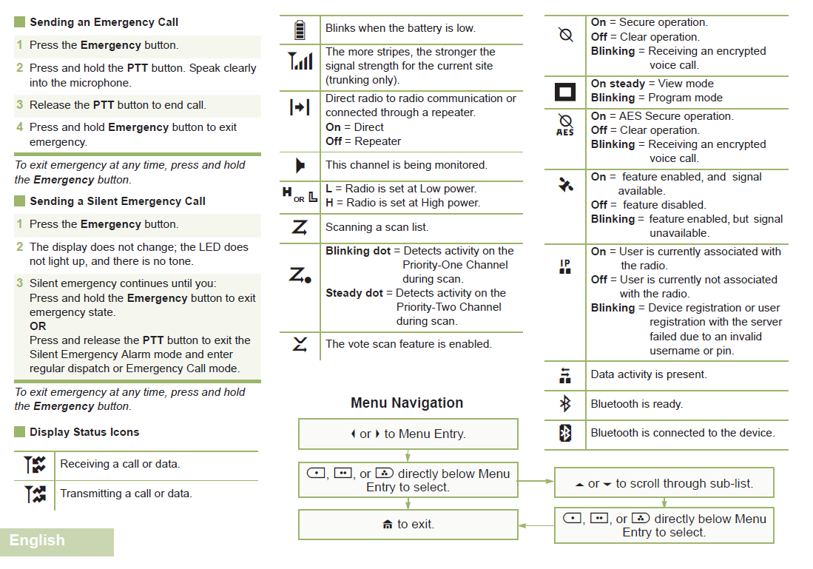

Color Code Key for Portable Radio Base Charger:
Solid Green | Ready for Use
Blinking Green | Ready for Use/Use solid green first
Solid Yellow | Battery Cycling “Do Not Remove”
Solid Red | Battery Charging “Do Not Use”
Blinking Red and Green light | Indicates your battery is going out and needs replacement
Flashing Red | Battery is no longer good “Contact Theresa Smith x3782”

Appendix E: Satellite TV Instructions
    - Get keys to Room 20:
Key rack in Room 106 OR Key hook on Cubicle 22 (Public Health Administration)
    - Open Room 20
    - Pull down projector screen
    - Open lower cabinets
    - Get remote control for projector from far right hand cabinet:
      - Aim at screen and power on
      - Select “Video” button
    - In lower left hand cabinet:
      - Turn on amplifier; push button for “Sat TV”
      - Get satellite remote control; power on
      - Select channel as you would any other TV
    - TV images should appear on screen

Troubleshooting:
No sound: Turn on amplifier, be sure “SAT TV” button is selected; test by selecting “Radio” button – be sure sound is turned down before you test!
PC Image on screen: Get the remote for the ceiling projector and push the “video” button
No image on screen/no input device detected: Get the remote for the satellite receiver, push the “power” button – a blue light should appear on the unit indicating the power is on

Appendix F: Scout Contact Information

(650) 670-xxxx

Name | Division | City of Residence | Cell Phone
 | AAS | Foster City
 | AAS | Redwood City
 | AAS | Sunnyvale
 | AAS | Pacifica
 | BHRS | Palo Alto
 | BHRS | Petaluma
 | BHRS | Petaluma
 | BHRS | San Mateo
 | BHRS | San Mateo
 | BHRS | San Mateo
 | BHRS | Oakland
 | BHRS | Pacifica
 | BHRS | Pacifica
 | BHRS | San Francisco
 | FH | Pacifica
 | FH | Daly City
 | FH | San Mateo
 | FH | San Mateo
 | PH | Foster City
 | PH | San Mateo
 | PH | San Francisco

Appendix G: Human Services Agency Contact List

Name | Work | Cell | Home
Name
Emergency Response Coordinator
Name
Deputy Emergency Response Coordinator /
Emergency Communications Lead
Name
Director of Emergency Response & SMC Works
Name
Agency Director
Name
Director’s Executive Analyst
Name
Directors Executive Secretary
Name
Public Information Officer
Name
Director-Admin and Information Services
Name
Director, CFS
Name
Director, Self Sufficiency
Name
Interim Director- Prevention & Intervention

Appendix H: Updating This Document

Process and Timeline for Updating Document and Resources:

What Needs to be Updated | Who is Responsible | When will this be done | Notes
Executive Emergency Resources Document (this document) | Administrative Assistant to Director of PHPP (Name) | Twice a Year; February and September | Distributed to HEC twice a year in March and October
Health System Contact List | Executive Assistant to the Chief (Name) | Ongoing | Added to document twice a year with update
HSDO Schedule | Executive Assistant to the Chief (Name) | Once a year in January | Training provided once a year as well
Scout Schedule | Public Health Emergency Preparedness Manager (Name) | Once a year in January | Training provided once a year as well
EMSystems | TBD | Weekly at start of HSDO shift | Only if contact # to change
Public Safety Communications CAP Code Participants | Public Health Emergency Preparedness Manager (Name) | Twice a Year in February and September
PIO Contact Information | Name | Ongoing | Added to document twice a year with update
AT&T Conference Line | Public Health Emergency Preparedness Staff (Name) | Twice a Year in February and September | Added to document twice a year with update
GETS Cards Participants | Public Health Emergency Preparedness Manager (Name) | Twice a Year in February and September | Added to document twice a year with update
CAHAN Enrollment | CAHAN Coordinator  (Name) | Ongoing | Added to document twice a year with update
Portable Radio Assignments | PHEP Staff  (Name) | Ongoing | Added to document twice a year with update
DOC Team Assignments | PHEP Staff  (Name) | Ongoing | Added to document twice a year with update

